DEALS TO BROOKLYN

Brooklyn is a New York borough with a personality all its own. Home to many of New York’s top attractions, a thriving music scene, and various diverse communities with their own special contributions, Brooklyn is one fun place to be for both residents and visitors. Book a trip to Brooklyn via LaGuardia International, John F. Kennedy International Airport or Newark Liberty International Airport on Virgin America. Live it up at 35,000 feet with WiFi, on-demand entertainment, and more on every flight.

(MARKET IMAGE HERE)

Find Deals From These Cities

INSERT FARE GRID FROM / TO Version (if available!)



Top Things To Do in Brooklyn

If you’ll be visiting Brooklyn, you’ll want to check out these top things to do while you’re there.

* Take a walk across the Brooklyn Bridge and enjoy the amazing views of lower Manhattan and other city landmarks, like the Statue of Liberty.
* Visit the Brooklyn Botanic Garden. With hundreds of types of flora spread over 52 acres, there’s a lot of beauty to take in here. If visiting in the spring, put Sakura Matsuri (BBG’s annual cherry blossom festival) on your agenda.
* Explore Brooklyn Bridge Park. This park offers many distinct attractions, including a restored 1920’s merry-go-round, picturesque riverside esplanades, and Pier 2, which has activities such as roller skating, sports, and more.
* Shop for unique items at the Brooklyn Flea. With antiques, vintage clothing, art, and jewelry, even if you don’t find something you love, you’ll have fun just looking at everything. Stop by one of the great food vendors for a sweet treat before you leave!

Travel Tips and Resources

[Must-Dos in Brooklyn](http://www.bkmag.com/2013/07/15/top-10-things-you-can-only-do-in-brooklyn/)

[Brooklyn Hotels](http://www.tripadvisor.com/Hotels-g60827-Brooklyn_New_York-Hotels.html)

[Brooklyn Restaurants](http://ny.eater.com/maps/best-new-brooklyn-restaurants-heatmap)

[Brooklyn Shopping Guidehttp://brooklyn.about.com/od/shoppingservices/a/Where-Is-The-Best-Shopping-In-Brooklyn.htm](http://brooklyn.about.com/od/shoppingservices/a/Where-Is-The-Best-Shopping-In-Brooklyn.htm)

[Brooklyn Nightlife and Entertainmenthttp://www.nyctourist.com/nightlife-brooklyn](http://www.nyctourist.com/nightlife-brooklyn)

[Brooklyn Travel Tipshttp://brooklyn.about.com/od/visitingbrooklyn](http://brooklyn.about.com/od/visitingbrooklyn)

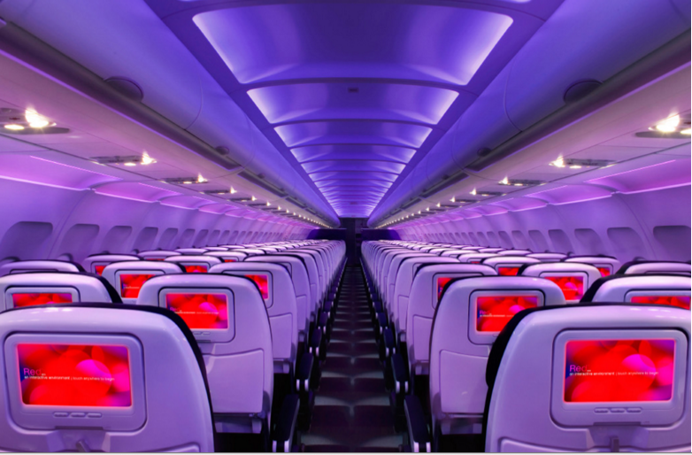

Main Cabin Main Cabin Select First Class

(add links to Cabin Class Pages)

Ready. Set. Fly.

Book your Mood-lit Ride to Brooklyn.

Book a Virgin America flight to Brooklyn through LaGuardia International, John F. Kennedy International Airport or Newark Liberty International Airport. You’ll love all the amenities available on our flights, such as our custom-designed leather seats and our on demand food ordering. When you fly with us, you’ll enjoy a truly comfortable, convenient and relaxing flight.

Take a Virtual Tour

Add Terms & Conditions